Computer Architecture Project Documentation

Who wants to be a Millionaire - MIPS

By: Anjali Prabhala NetID: axp171330 Course: CS 3340 - 502



# Description:

This project is an ascii based game inspired by “Who wants to be millionaire”, popular trivia game TV Show. It allows the user answer quiz questions and based on user input increments the score and money and moves forward till the user becomes a millionaire (wins $ 1M dollars) or answers a question incorrectly. It’s a great way to pass time and can be played multiple times until the user wants to quit/ Exit or if he gives a wrong answer to the question, he/she will be exited out of the game.

Rules/ How to play:

* Start the game and answer the questions. With each question, the player wins a specific amount as shown below in the table:
* To get additional information on the rules, **press 2** in the main menu for the game.

|  |  |
| --- | --- |
| Question Number | Amount of money |
| 1 | $100 |
| 2 | $500 |
| 3 | $1000 |
| 4 | $2000 |
| 5 | $6000 |
| 6 | $12000 |
| 7 | $25000 |
| 8 | $32000 |
| 9 | $64000 |
| 10 | $125000 |
| 11 | $500000 |
| 12 | $1000000 (1 MILLION) |

## User Manual:

|  |  |  |
| --- | --- | --- |
| Instruction | Solution | Details |
| Interacting with the game | User friendly menu | 1 – Start game OR play again  2 – Display rules for the game  3 – Exit  -1 – Default exit from program |
| Answering quiz questions | Multiple choice | 1, 2, 3 or 4 (instead of a, b, c, d) |
| Continue? | If user wants to continue in the middle of the game | 1 or 2 (instead of Y or N) |
| Exit? | If user wants to exit in the middle of the game or anytime when the program is running | Press -1 |
| Unlimited play(s) | Play again | * After the user wins, he/she has the choice to play again. * When the user loses, he/she is directed back to the main menu where you can attempt to play again. |
| Game Modes | 3 modes | 1 – General knowledge  2 – Harry Potter  3 – TV Shows  4 – Back to main menu  -1 – Default exit from program |

## How to run the project:

Step 1: Open the Mars4_5.jar from the downloaded project folder.

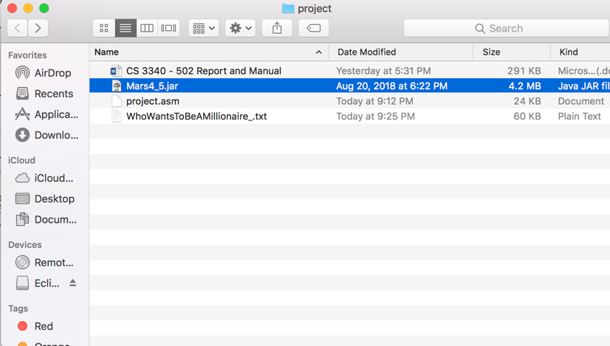

Step 2: Open the project.asm file, assemble it and then run it. Follow the video below for the following (To view: **Right click + Play**).

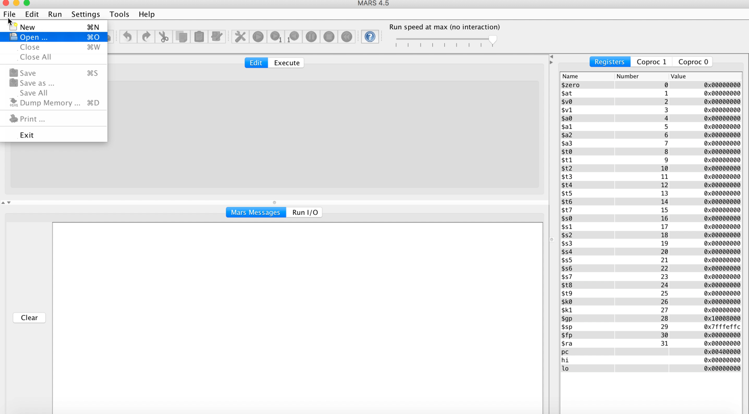

Step 3: Make sure your main menu looks like the screenshot below. If you want to test the project again and this screen does not show up, be sure to refresh MIPS:

1. Clear the Run IO
2. Save the file
3. Assemble
4. Run

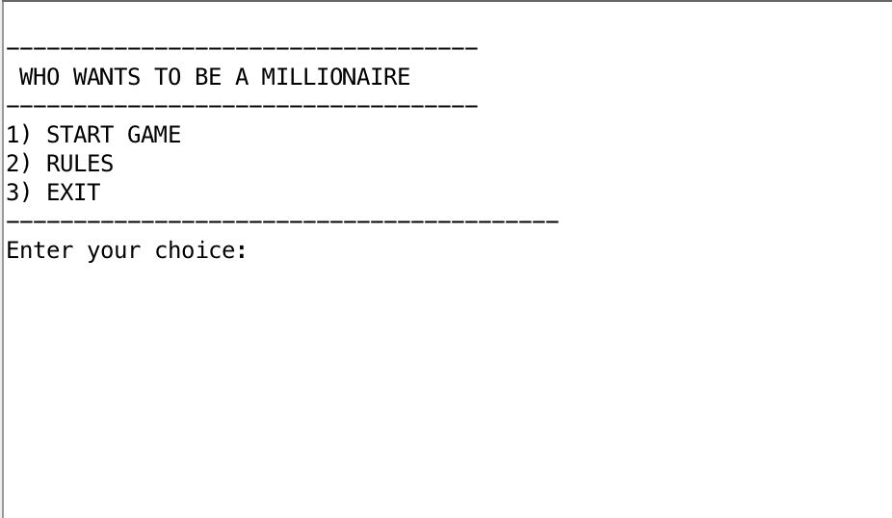

## What makes it unique:

**Three modes**

General Knowledge: Trivia questions testing broad areas of general topics like Chemistry, Biology, Politics, Vocabulary, Entertainment, Cars, and many more.



Harry Potter: Harry potter quiz questions that only Ravenclaws will be able to solve. Are you sure you are ready for this, muggle? This mode has questions from all the 8 harry potter books/ movies.



TV Shows: Do you watch as much TV as I do? Prove it! These trivia questions are based on various TV Shows such as Game of Thrones, Stranger things, thirteen reasons why, Breaking bad, Simpsons, etc. to name a few.

## Challenges:

* Length of the code and questions research: As I had three modes, I had to write a lot of code for printing out and taking input for each question. In addition, I had trouble finding unique and interesting questions online for each mode as I didn’t want my game to be repetitive and easy.
* Multiple loops, logic and pseudocode
* Input Validation: I have included basic input validation that checks for user input and does not crash. Input validation in MIPs was more challenging than in any high-level programming language like Java, C or C++.